**PROJECT REPORT ON**

NAVKAR FITTINGS CORPORATION

**UNDER THE GUIDANCE OF**

**Ms Nawal Dandekar**

**&**

**Prof. Mrs. Krupa Balsara Kamdar**

**UNIVERSITY OF MUMBAI**

**T.Y.B.Sc (COMPUTER SCIENCE)**

**ACADEMIC YEAR: 2021-2022**



**BHARTIYA VIDYA BHAVAN’S**

**MM COLLEGE OF ARTS, NM COLLEGE OF COMMERCE &**

**HRJ COLLEGE OF COMMERCE**

**BHAVAN’S COLLEGE**

**MUNSHI NAGAR, ANDHERI (WEST),**

**MUMBAI – 400058**

BHARATIYA VIDYA BHAVAN

**BHAVAN’S COLLEGE, ANDHERI (W)**

**CERTIFICATE**

This is to certify that **NIKHIL AJEET SINGH** of the class

T**. Y. B. Sc. Computer Science** has satisfactorily completed the practical course in **Group 5** as prescribed by the University of Mumbai during the academic year **2021 – 22**.

Signature Signature

**Staff in charge**  **Computer Science Coordinators**

Signature

**CLIENT CERTIFICATE**



ACKNOWLEDGEMENT

 I would like to express my sincere gratitude towards the Computer Science  Department of Bhavan’s College.

After months of hard work, finally I am very happy to present my Sem 5 Project.  The Project making was full of new experiences and learning and difficult one too.  Though a difficult job it was made simpler by the timely guidance received, which helped  me greatly in the completion of my project. But it wouldn’t be right to do so without  thanking to those who have helped me in converting our thought into reality. So, I would  like to take full advantage of this opportunity to thank each and every person who has  helped me throughout the completion of our project.

I am obliged to my parents & family members who always support me greatly and  encouraged me in each and every step. I give my special thanks and sincere gratitude  towards the Principal Dr. Zarine Bhathena and Head of Department (Computer Science)  Prof. Mrs. Krupa Balsara-Kamdar.

I owe my sincere thanks to our Project guide Mrs Krupa Balsara-Kamdar for her constant  support and encouragement without which the successful completion of this project  would have been impossible. They have been instrumental for making me concentrate  and focus my effort in this project. And last but not the least the entire college staff  specially Mr. Prathamesh N. Rane.

I would like to give thanks to my friends for helping me in my project. Finally, I  would like to thank each and every individual who was directly or indirectly contributing  for this project.

**-Thank you**

**Index**

|  |  |  |
| --- | --- | --- |
| **Sr. No.** | **Topics** | **Page No.** |
| **1.** | **Preliminary Investigation** | **8** |
|  | * 1. Organizational Overview/Introduction | 9 |
| * 1. Description of System | 9 |
| * 1. Limitations | 9 |
| * 1. Proposed system and Number of Modules | 10 |
| * 1. Requirement Specification: software/hardware/data requirement | 11 |
| * 1. Gantt Chart | 11 |
|  |  |
| **2.** | **System Analysis** | **12** |
|  | * 1. Fact Finding Techniques (Questionnaire, Sample Reports, Forms...) | 13 |
| * 1. Event Table | 14 |
| * 1. Use Case Diagram | 16 |
| * 1. ERD | 17 |
| * 1. Class diagram | 18 |
| * 1. Object Diagram | 19 |
| * 1. Activity Diagram | 20 |
| * 1. Sequence diagram | 21 |
| * 1. Collaboration Diagram | - |
| * 1. Methodology | - |
| * 1. Algorithm | - |
| * 1. DFD | - |
| * 1. Architecture | - |
| 2.14. Protocol | - |
|  |  |
| **3.** | **System Design** | **22** |
|  | * 1. Component Diagram | 23 |
| * 1. Package Diagram | - |
| * 1. Deployment Diagram | 24 |
|  |  |
| **4.** | **System Coding** | **25** |
|  | * 1. Menu Tree | 26 |
| * 1. List of tables with attributes and constraints | 28 |
| * 1. Program Description [ Programs /Classes and their responsibilities in brief ] with Naming Conventions. | 30 |
| 4.5 Validations | 36 |
| 4.6 Test Cases, Test Data and Test Results | 38 |
| 4.7 Screen Layouts & Report Layouts | 40 |
|  |  |
| **5.** | **Conclusion&Future Scope** | **50** |
|  |  |  |
| **6.** | **References, Books, web links, research articles, etc.** | **51** |

**LIST OF TABLES:**

| **Sr.no** | **Table name** |
| --- | --- |
| **1** | **Use case description table** |
| **2** | **Event table** |
| **3** | **Validation table** |
| **4** | **Test case table** |

**LIST OF FIGURES:**

| **Sr.no** | **Figure name** |
| --- | --- |
| **1** | **E- R diagram** |
| **2** | **Class diagram** |
| **3** | **Object diagram** |
| **4** | **Use case diagram** |
| **5** | **Activity diagram** |
| **6** | **Sequence diagram** |
| **7** | **Deployment diagram** |
| **8** | **Component diagram** |
| **9** | **Menu tree** |

**1.**

**PRELIMINARY INVESTIGATION**

**1.1 Organizational Overview**

Navkar Fittings Company is a leading manufacturer of all types of Pipe Fittings viz. M.S. Pipe Fittings, S.S. Pipe Fittings, etc, catering to the industries like Pharma, Oil & Gas, Manufacturing, Chemical and Dairy Industries.

Our dedication and commitment towards the quality of our products, maintenance of our plant, higher productivity and trained and skilled Human Resources has helped to us sustain for more than 15 years in the industry.

Our vision is to become the leading company in S.S & Pipe-Fitting products and related businesses. Navkar is committed to provide quality products to its customers as per standard and best suited to local environment at affordable price.

**1.2 Description of the existing system**

• Deployed at <http://www.navkarengg.com/>

• Made in php + html +css +js

• No database involved

• Completely static

**1.3 Limitation of the present system.**

• Bad UI

• Static website

• Old look

• No interactivity with users

• Redundant products are still listed

• Not at all organized

• automated mailing doesn’t work

**1.4 The proposed system**

• better UI

• More interactive surface

• faster loading

• Admin panel to update products and website info

• To collect customer information and interests on products

• automated mailing system

**Advantages of proposed system**

• Admin will be able to add /update/delete products as per requirement

• Admin will be able to update website info as per requirement

• Better UI and interactivity will bring in more customers

• Customers can place requests easily

• Website will be organized and future updates will be easy

• customer and admin will be notified through mailing system

**Number of modules in the proposed system**

• Admin

• Customer

• Product

• Request

• Email (optional module)

1.5 Requirements and FEASIBILITY STUDY

**Technical Feasibility**

**Hardware Requirements**

* + - 1. Intel i3 or higher.
      2. 1 GB RAM.
      3. >1 GB Hard-disk space.

**Software Requirements**

* + - 1. Windows 7 or higher, any Linux distro
      2. Google Chrome or Firefox Browser.

**Operational Feasibility**: This project is operationally feasible, easy to handle with basic input, the user interface is easily interact by user. The Operation of adding, updating, deleting is easy to handle. The database connectivity is provided by Developer.

**Economic Feasibility**: this project can be deployed on any webhosting platform supporting php and mysql. First time deployment will be done for free by developer after current domain expires.

1.6 Gantt Chart

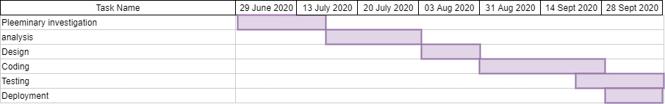

**2.**

**SYSTEM ANALYSIS**

**2.1 Fact Finding Techniques (Questionnaire, Sample Reports, Forms...)**

**Questionnaire**

• Do you have any existing website?

• . What should be the name of the website?

• Do you have any color scheme preferences for your website?

• Does the admin need to login?

• What is the basic information required for the customer to register into the website?

• Is it necessary for the customers to login to place an request?

• How do customers place a customized request?

2.2 **EVENT TABLE:**

**TRIGGER:**

Trigger an occurrence that tells the system that has occurred, either the arrival of data needing or of a point in time

**SOURCE:**

An external agent or actor that supplies data to the system

**ACTIVITY:**

Behavior that the system performs when an event occurs

**RESPONSE:**

An output produced by the system that goes to a destination.

**DESTINATION:**

An external agent or actor that receives data from the system

**Table: 1. Login/Register Use Case**

| |  | | | --- | --- | | **Use Case Name** |  | | Log-in/Register |
| --- | --- | --- | --- | --- | --- |
| **Summary/Description** | Use case depicting how an Admin or Customer would login. |
| **Actors** | Admin and Customer |
| **Pre-Condiditons** | Log-in ID must be present in Login table for both Customer and Admin |
| **Descriptions** | Admin or Customer will have to login to land on their respective home pages. From here they can perofrm their respective actions. |
| **Exception** | No ID present in the Login table, which wll give them an error |
| **Trigger** | Trigger is activated when a new customer registers and this trigger notifies respective customer and admin through mail |
| **Post-Condition** | Admin and Customer successfully Login. |

**Table: 2. Customer Use Case**

| **Use Case Name** | Customer Use Case |
| --- | --- |
| **Summary/Description** | Use case depicting how an Customer will log-in and then perform his respective tasks from the web application |
| **Actors** | Customer and Admin |
| **Pre-Condiditons** | Customer Login ID must be present in the Login table enabling Customer to login |
| **Descriptions** | Once the Customer has logged in to the system, he can perform various tasks such as, Placing an Request,View Placed Requests, view contact info, view products, search products, logout |
| **Exception** | Customer ID is not present |
| **Trigger** | Trigger is activated when a new Request is made and this trigger notifies respective customer and admin through mail |
| **Post-Condition** | Customer is able to successfully log-in and perform all the actions he is authorized to. |

**Table: 3 Admin Use Case**

| **Use Case Name** | Admin Use Case |
| --- | --- |
| **Summary/Description** | Use case depicting how a system admin will be able to log-in and perform his respective tasks in the web application |
| **Actors** | Admin |
| **Pre-Condiditons** | Person trying to log-in must have adminstrative privileges. |
| **Descriptions** | Admin holds all the rights the system has to offer. He/She can create view, update delete products. Delete existing customers, update admin username ,email and password , and update contact info of the site |
| **Exception** | Person trying to log-in does not have administrator privileges. |
| **Post-Condition** | Admin is successfully able to log-in and perform tasks. |

2.3 USE CASE DIAGRAM

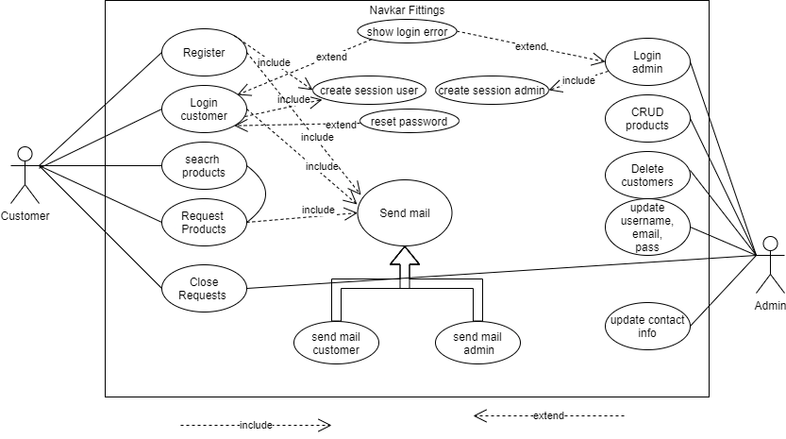

2.4 Enitity relationship DIAGRAM (erd)

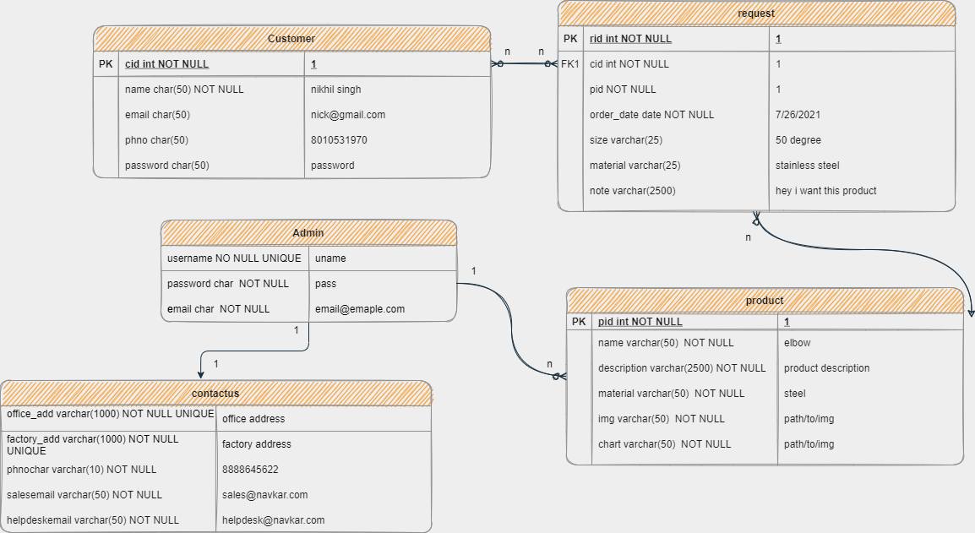

2.5 CLASS DIAGRAM

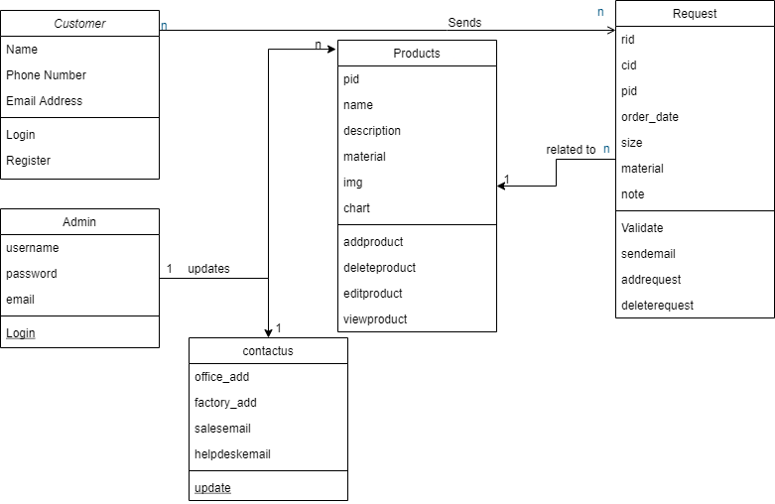

2.6 OBJECT DIAGRAM

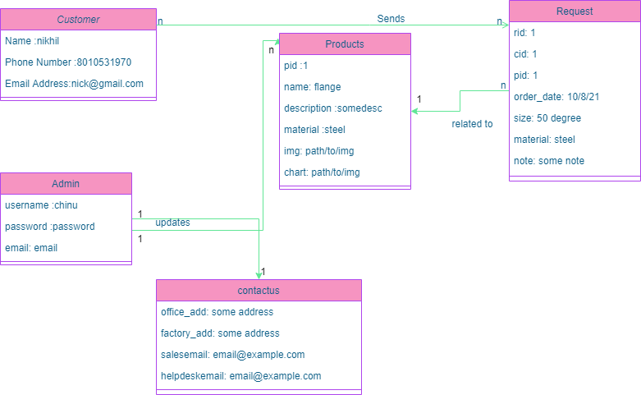

2.7 ACTIVITY DIAGRAM

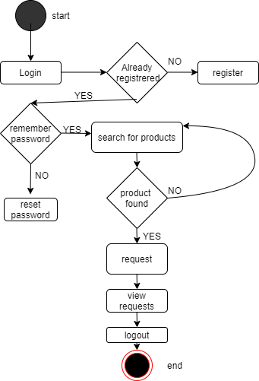

2.8 SEQUENCE DIAGRAM

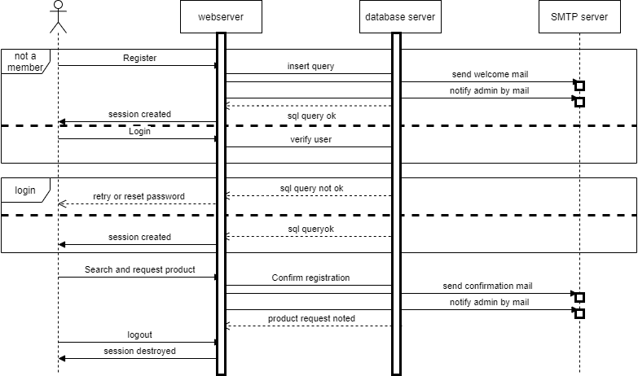

**3 . SYSTEM DESIGN**

3.1 COMPONENT DIAGRAM

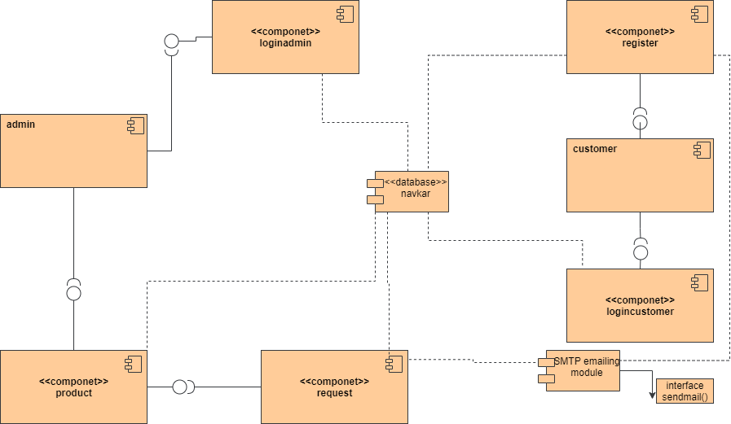

3.3 DEPLOYMENT DIAGRAM

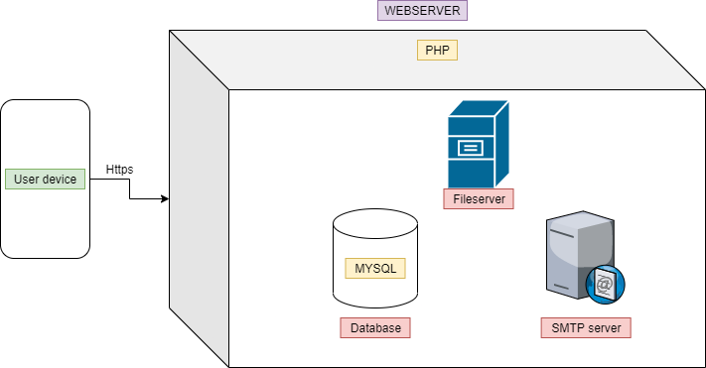

**4. SYSTEM CODING**

4.1 Menu Tree

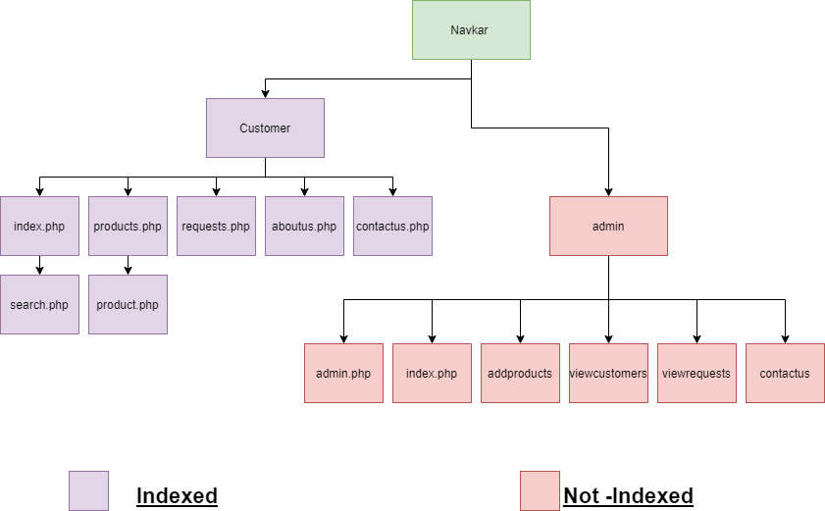

Sitemap

<?xml version="1.0" encoding="UTF-8"?>

<urlset xsi:schemaLocation="**http://www.sitemaps.org/schemas/sitemap/0.9 http://www.sitemaps.org/schemas/sitemap/0.9/sitemap.xsd**" xmlns:xsi="**http://www.w3.org/2001/XMLSchema-instance**" xmlns="**http://www.sitemaps.org/schemas/sitemap/0.9**">

<!-- created with Free Online Sitemap Generator www.xml-sitemaps.com -->

<url><loc>https://navkarfittings.000webhostapp.com/</loc><lastmod>2021-10-08T05:36:58+00:00</lastmod><priority>1.00</priority></url><url><loc>https://navkarfittings.000webhostapp.com/index.php</loc><lastmod>2021-10-08T05:36:58+00:00</lastmod><priority>0.80</priority></url><url><loc>https://navkarfittings.000webhostapp.com/aboutus.php</loc><lastmod>2021-10-08T05:36:58+00:00</lastmod><priority>0.80</priority></url><url><loc>https://navkarfittings.000webhostapp.com/products.php</loc><lastmod>2021-10-08T05:36:58+00:00</lastmod><priority>0.80</priority></url><url><loc>https://navkarfittings.000webhostapp.com/requests.php</loc><lastmod>2021-10-08T05:36:58+00:00</lastmod><priority>0.80</priority></url><url><loc>https://navkarfittings.000webhostapp.com/contactus.php</loc><lastmod>2021-10-08T05:36:58+00:00</lastmod><priority>0.80</priority></url><url><loc>https://navkarfittings.000webhostapp.com/login.php</loc><lastmod>2021-10-08T05:36:58+00:00</lastmod><priority>0.80</priority></url><url><loc>https://navkarfittings.000webhostapp.com/register.php</loc><lastmod>2021-10-08T05:36:58+00:00</lastmod><priority>0.64</priority></url>

</urlset>

4.2 TABLES WITH ATTRIBUTES AND CONSTRAINTS

**Customer**

**Table 1: Customer**

| **Field Name** | **Data Type** | **Constraint** | **Description** |
| --- | --- | --- | --- |
| cid | int | PRIMARY KEY | Id of customer |
| name | varchar(15) | NOT NULL | Name of customer |
| email | varchar(50) | NOT NULL | Email of customer |
| phno | varchar(10) | NOT NULL | Contact no of customer |
| password | varchar(10) | NOT NULL | Password of Customer |

**Admin**

**Table 2: Admin**

| **Field Name** | **Data Type** | **Constraint** | **Description** |
| --- | --- | --- | --- |
| username | varchar(10) | NOT NULL UNIQUE | Name of Admin |
| email | varchar(50) | NOT NULL | Email of Admin |
| password | varchar(10) | NOT NULL | Password of Admin |

**Contactus**

**Table 2: Contact us**

| **Field Name** | **Data Type** | **Constraint** | **Description** |
| --- | --- | --- | --- |
| Office_add | Varchar(1000) | NOT NULL | Office address |
| factory_add | Varchar(1000) | NOT NULL | Factory address |
| phno | varchar(10) | NOT NULL | Phone number |
| salesemail | varchar(50) | NOT NULL | Sales email |
| helpdeskemail | varchar(50) | NOT NULL | Help Desk email |

**Products**

**Table 3: Products**

| **Field Name** | **Data Type** | **Constraint** | **Description** |
| --- | --- | --- | --- |
| pid | int | PRIMARY KEY | Id of Product |
| name | varchar(25) | NOT NULL | Name of Product |
| description | varchar (2500) | NOT NULL | Details of Product |
| category | varchar(50) | NOT NULL | Category of Product |
| material | varchar(10) | NOT NULL | Type of Material Selected |
| Img | varchar(50) |  | Image path |
| chart | varchar(50) |  | Chart path |

**Requests**

**Table 4: Requests**

| **Field Name** | **Data Type** | **Constraint** | **Description** |
| --- | --- | --- | --- |
| rid | int | PRIMARY KEY | Id of request |
| pid | int | NOT NULL | Id of Product |
| cid | int | NOT NULL | Id of Customer |
| note | varchar (2500) |  | Note to seller |
| size | varchar(25) |  | Size of Product Requested |
| Request_date | Date | NOT NULL | Date of Request |
| material | varchar(25) |  | Type of material Selected |

**4.3 Program Description**

**Some important codes**

Functions.php

**(Functions for redirect verifying sessions and mailing code)**

<?php

function verifysession(){

if(isset($_SESSION["cid"]))

{

return true;

}

else{

return false;

}

}

function verifysessionadmin(){

if(isset($_SESSION["name"]))

{

return true;

}

else{

return false;

}

}

function Redirect($url, $permanent = false)

{

/* if (headers_sent() === false)

{

header('Location: ' . $url, true, ($permanent === true) ? 301 : 302);

}

*/

echo("<script>location.href = '$url';</script>");

exit();

}

function sendamail($to,$subject,$content){

require ('smtp/PHPMailerAutoload.php');

$mail = new PHPMailer();

try {

//Server settings

//$mail->SMTPDebug = SMTP::DEBUG_SERVER; //Enable verbose debug output

$mail->isSMTP(); //Send using SMTP

$mail->Host = 'smtp.gmail.com'; //Set the SMTP server to send through

$mail->SMTPAuth = true; //Enable SMTP authentication

//$mail->SMTPDebug=3;

$mail->Username = 'somemail@gmail.com'; //SMTP username

$mail->Password = 'somepass'; //SMTP password

//$mail->SMTPSecure = PHPMailer::ENCRYPTION_STARTTLS; //Enable implicit TLS encryption

$mail->SMTPSecure='tls';

$mail->Port = 587; //TCP port to connect to; use 587 if you have set `SMTPSecure = PHPMailer::ENCRYPTION_STARTTLS`

//Recipients

$mail->setFrom('recruit.my.freelancer@gmail.com', 'Navkar');

$mail->addAddress($to); //Add a recipient

// $mail->addReplyTo('info@gmail.com', 'Information');

//$mail->addCC('cc@gmail.com');

// $mail->addBCC('bcc@gmail.com');

//Content

$mail->isHTML(true); //Set email format to HTML

$mail->Subject = $subject;

$mail->Body = $content;

$mail->send();

// echo 'Message has been sent';

} catch (Exception $e) {

//echo "Message could not be sent. Mailer Error: {$mail->ErrorInfo}";

}

}

?>

header.php

**(code for included header in all customer files)**

<?php

session_start();

?>

<?php require("head.php"); ?>

<body>

<header>

<nav class="flex flex-spacearound">

<ul class="flex flex-spacearound widthfull " id="collapseul">

<li class="inactive">

<div id="collapse" class="collapse">

<img src="https://img.icons8.com/material-outlined/24/ffffff/menu--v1.png"/>

</div>

</li>

<li class="nilactive">

<img src="./img/Logo.png" hieght="50px" width="50px">

</li>

<li class="nilactive">

<div>

<?php

if(verifysession()){

$sql="SELECT name FROM customer where cid=".$_SESSION['cid'];

$result=mysqli_query($conn,$sql);

while($rows=mysqli_fetch_array($result)){

?>Welcome <?php echo $rows[0];?>

<?php

}

}

else{

?>

Navkar Fittings Corporation

<?php

}

?>

</div>

</li>

<li class="active"> <a href="./index.php"> Home </a></li>

<li class="active"> <a href="./aboutus.php"> About Us </a> </li>

<li class="active"> <a href="./products.php"> Products </a> </li>

<li class="active"> <a href="./requests.php"> Requests </a> </li>

<li class="active"> <a href="./contactus.php"> Contact us </a> </li>

<li class="active"> <a href="./login.php">

<?php

if(!verifysession()){

echo "Login";

}

else

{echo "Logout";}

?>

</a> </li>

</ul>

</nav>

</header>

footer.php

**(code for footer included in all files)**

<footer class="text-center">

<script>

collapser();

</script>

<a class="colorwhite" href="https://codewithnick.github.io/">

This Site is Made By @codewithnick

</a>

</footer>

</body>

</html>

search.php

**(code for searching of a product)**

<?php include("header.php"); ?>

<?php include("connection.php"); ?>

<div style="height:fit-content;">

<div>

<div class="sizefull flex flex-center flex-col ">

<?php

if(isset($_GET['s'])){

$s="%".$_GET['s']."%";

$sql="SELECT * FROM product Where name LIKE '$s' or category LIKE '$s' or description LIKE '$s' or material LIKE '$s' ORDER BY name";

$result=mysqli_query($conn,$sql);

while($rows=mysqli_fetch_array($result)){?>

<!--start here -->

<div class="card product-card flex flex-spacearound">

<img src="<?php echo $rows['img'];?>" class="product-img">

<div class="sizefull product flex flex-col ">

<div class="product-title text-left">

<?php echo $rows['name']?>

</div>

<div class="text-left">

Category: <?php echo $rows['category']?>

</div>

<div class="product-material text-left">

Material: <?php echo $rows['material']?>

</div>

<div class="product-desc text-left textgrey">

<?php echo $rows['description']?>

</div>

<div class="text-right">

<a href=<?php echo "./product.php?pid=".$rows["pid"]?>> View More...</a>

</div>

</div>

</div>

<!--end here -->

<?php

}}?>

</div>

</div>

</div>

<?php include("footer.php"); ?>

**4.5 VALIDATIONS**

**Customer**

**Table 1: Customer**

| **Field Name** | **Valid values** | **Invalid values** |
| --- | --- | --- |
| cid | 1,2,3 | A,b,c |
| name | abc | Abc123 |
| email | Abc.@pqr.xyz | Abc.v |
| phno | 1111111111 | Abc |
| password | Abed3822,32n,#bfu | - |

**Admin**

**Table 2: Admin**

| **Field Name** | **Valid values** | **Invalid values** |
| --- | --- | --- |
| username | abc | Abc123 |
| email | Abc.@pqr.xyz | Abc.v |
| password | Abed3822,32n,#bfu | - |

**Contactus**

**Table 2: Contact us**

| **Field Name** | **Valid values** | **Invalid values** |
| --- | --- | --- |
| Office_add | abc | - |
| factory_add | abc | - |
| phno | 1111111111 | Abc |
| salesemail | Abc.@pqr.xyz | Abc.v |
| helpdeskemail | Abc.@pqr.xyz | Abc.v |

**Products**

**Table 3: Products**

| **Field Name** | **Valid values** | **Invalid values** |
| --- | --- | --- |
| Pid | 1,2,3 | A,b,c |
| name | abc | Abc123 |
| description | Abc123 | - |
| category | Abc123 | - |
| material | Abc123 | - |
| Img | Path/to/file.extension | $%#%12 |
| chart | Path/to/file.extension | #$#% 154 |

**Requests**

**Table 4: Requests**

| **Field Name** | **Constraint** | **Description** |
| --- | --- | --- |
| Rid | 1,2,3 | A,b,c |
| Pid | 1,2,3 | A,b,c |
| cid | 1,2,3 | A,b,c |
| Note | Abc123 | - |
| Size | Abc123 | - |
| Request_date | 22-01-2022 | 22012022,abc,#$@$ |
| Material | Abc123 | - |

**4.6 TEST CASES, TEST DATA, TEST RESULT**

**Table 1: Test Case Table**

| **Test Case Id :** | **Module (Unit to be tested)** | **Why?** | **Desired Output** | **Observed Output** | **Pass or Fail** |
| --- | --- | --- | --- | --- | --- |
| 1 | Authentication & Login | Providing login into the system only for authentic users. | Access should be provided only after proper check of username and password. | Access was provided only after proper check of username and password. | Pass |
| 2 | Adding Customer | Admin can add new Customer | Adding feature should be provided on registration | Adding feature was provided | Pass |
| 3 | Deleting Customer Details | Only Admin can delete details. | Deleting feature should be provided to the Admin. | Deleting feature was provided to the Admin. | Pass |
| 4 | Viewing Customer  Details | Only Admin can view details of Customer | Viewing Customer details should be provided to the Admin. | Viewing an Customer details was provided to the Admin details. | Pass |
| 5 | Adding Products | Only Admin can add new Products. | Adding feature should be provided to the admin. | Adding feature was provided to the Admin. | Pass |
| 6 | Updating Products | Only Admin can update Product details. | Updating feature should be provided to the admin to update their Product details. | Updating feature was provided to the admin. | Pass |
| 7 | Deleting Products | Only Admin can delete Products. | Deleting feature should be provided to the Admin. | Deleting feature was provided to the Admin. | Pass |
| 8 | Customer Registration | Only Customer can Register himself. | Registering feature should be provided to the Customer. | Registration feature was provided to the Customer. | Pass |
| 9 | Place Request | Only Customer can place Request | Request Placing feature should be provided to the Customer | Request placing feature was provided to the Customer. | Pass |
| 10 | View Placed Request | Admin and customer can view Placed Requests | Viewing Requests feature should be provided to the Admin and customer | Viewing Requests feature was provided to the Admin and customer | Pass |
| 11 | Delete Placed Request | Admin and customer can Delete Placed Requests | Delete Requests feature should be provided to the Admin and customer | Delete Requests feature was provided to the Admin and customer | Pass |
| 12 | Deleting Customers | Only Admin can delete Customers | Deleting feature should be provided to the Admin. | Deleting feature was provided to the Admin. | Pass |
| 13 | Search | Only Customer can Search  products | Search feature should be provided to the Customer | Search feature was provided to the Customer. | Pass |
| 14 | Send mail | Admin and customer recieve mail | Admin and customer Should recieve mail on customer resigtraion and product request | Admin and customer recieve mail on customer resigtraion and product request | pass |

# 4.7 SCREEN LAYOUT AND REPORT LAYOUT

**Index.php**

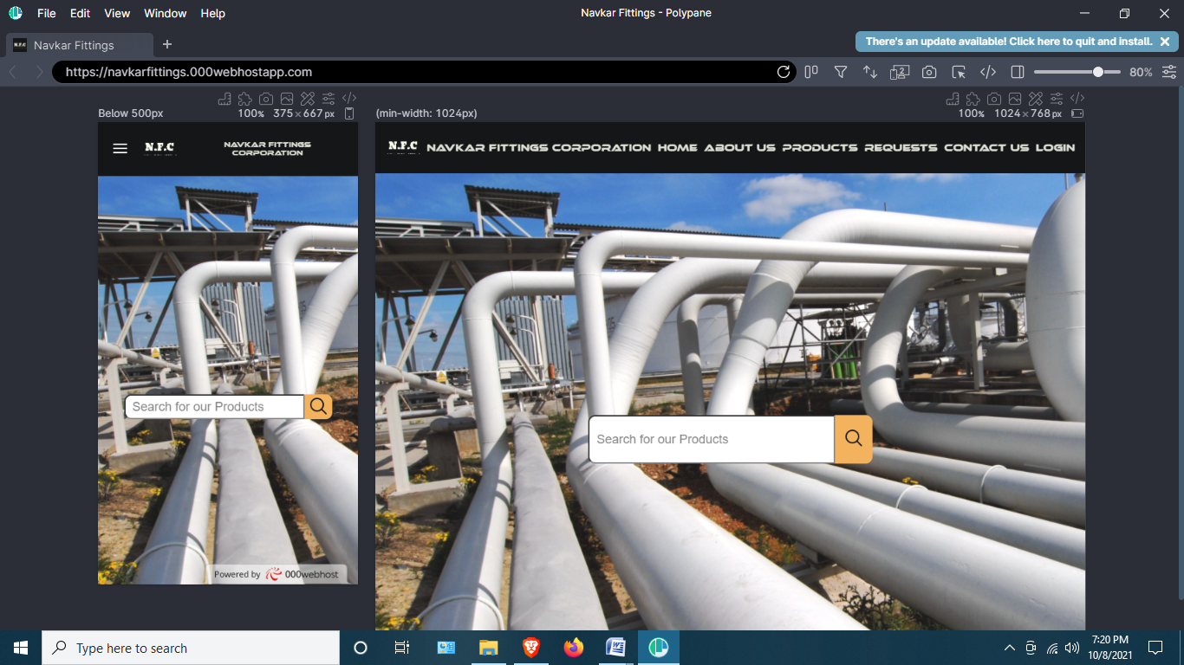

**SEARCH.PHP**

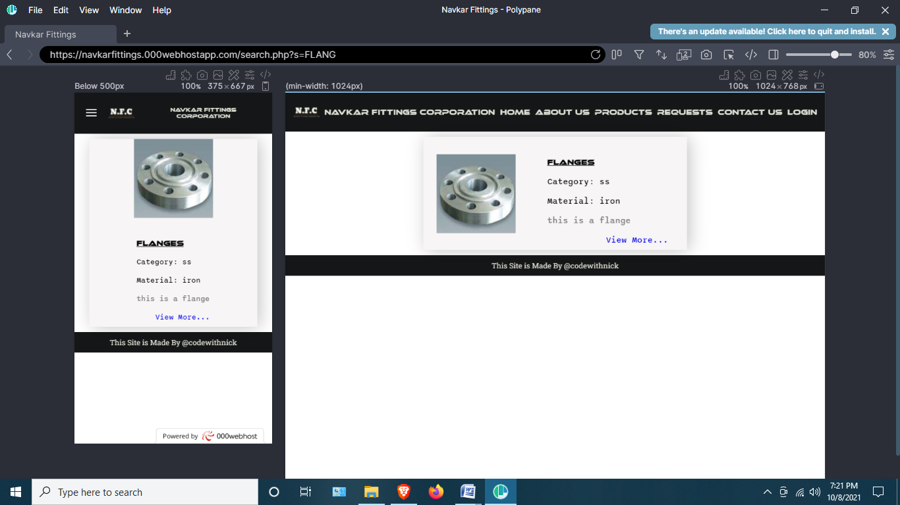

**ABOUTUS.PHP**

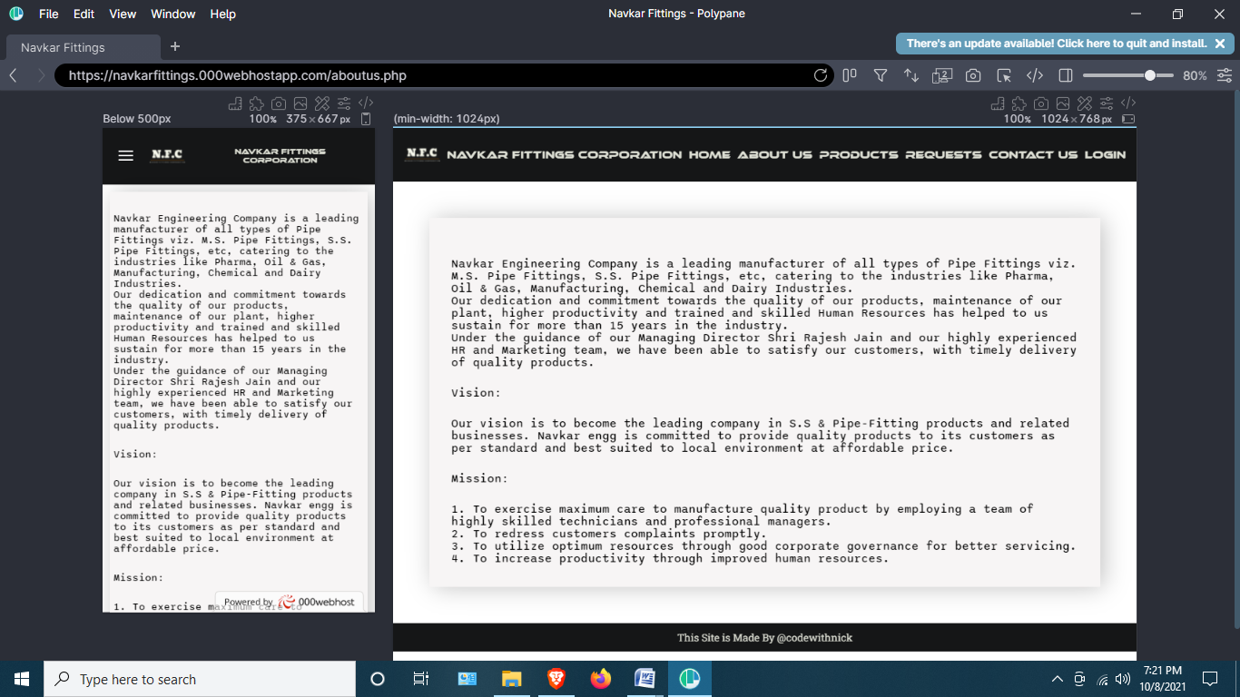

**PRODUCTS.PHP**

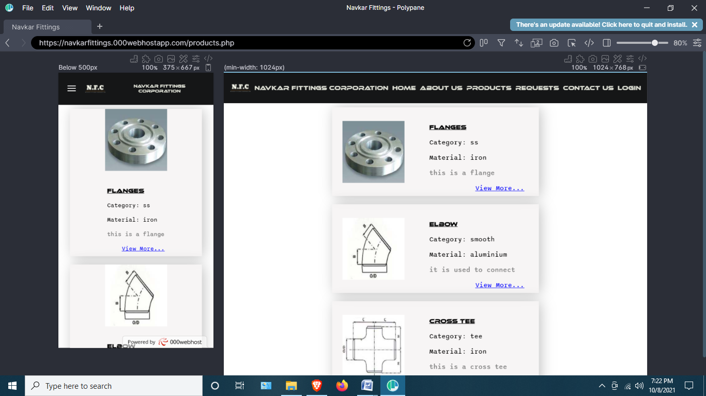

**CONTACTUS.PHP**

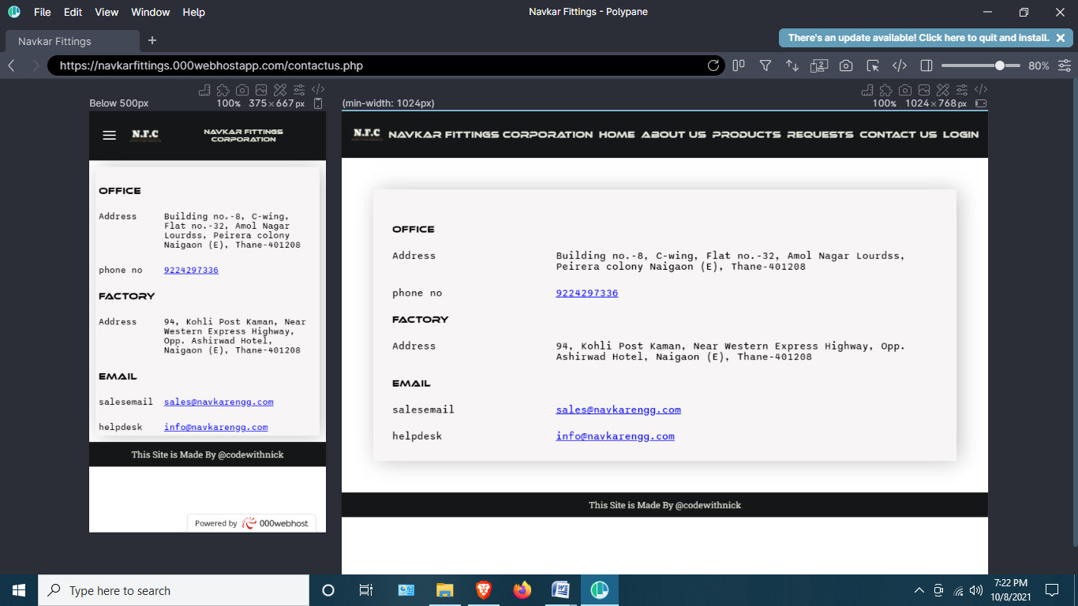

**REGISTER.PHP**

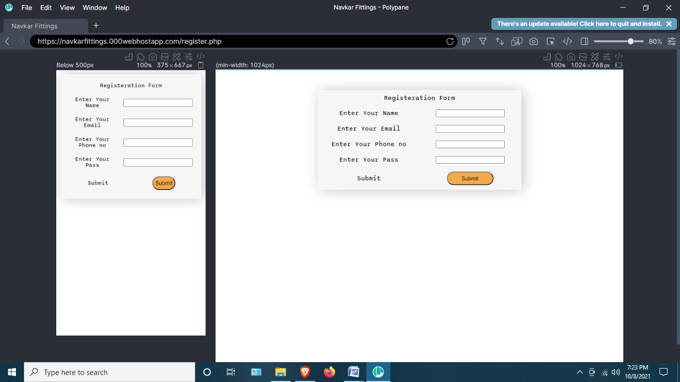

**LOGIN.PHP**

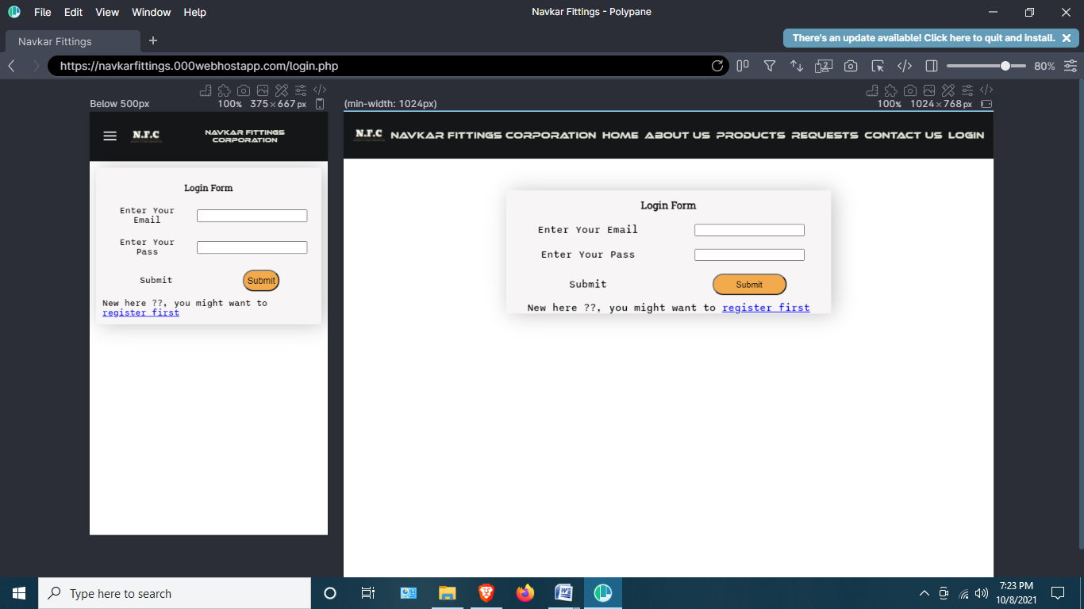

**RESETPASS.PHP**

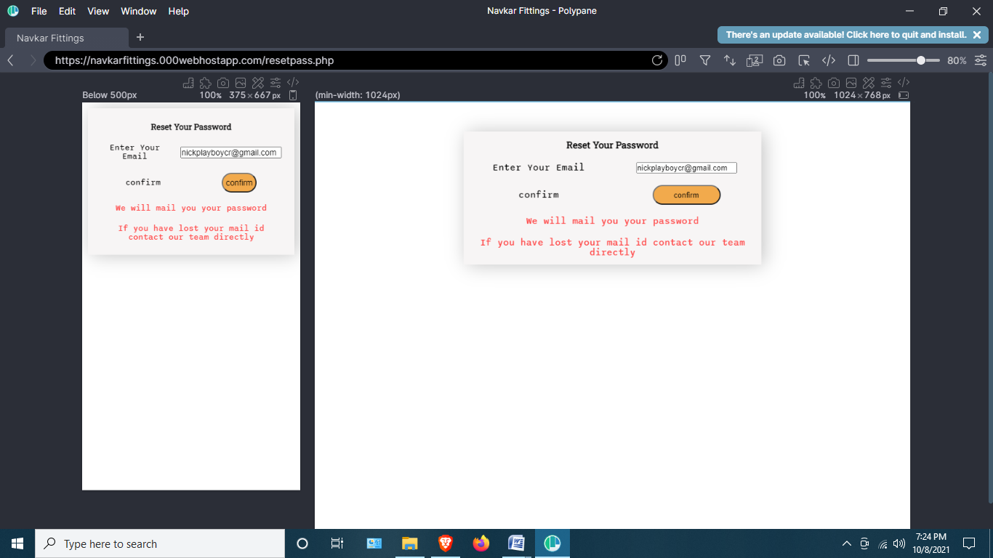

**ADMINLOGIN.PHP**

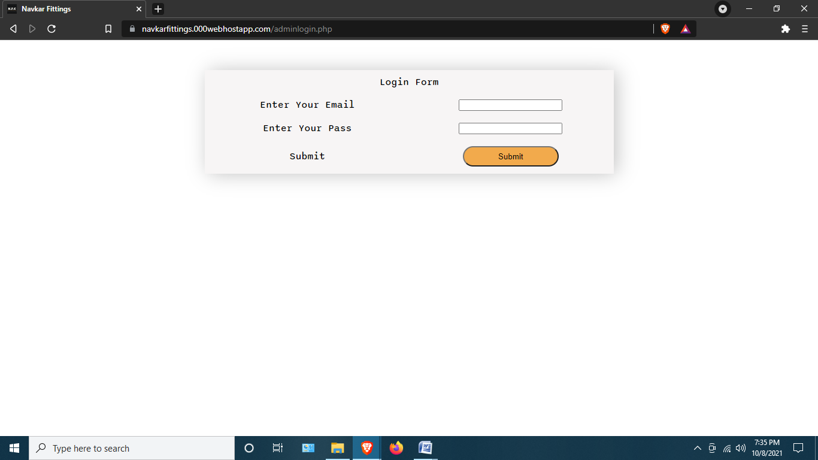

PRODUCT.PHP

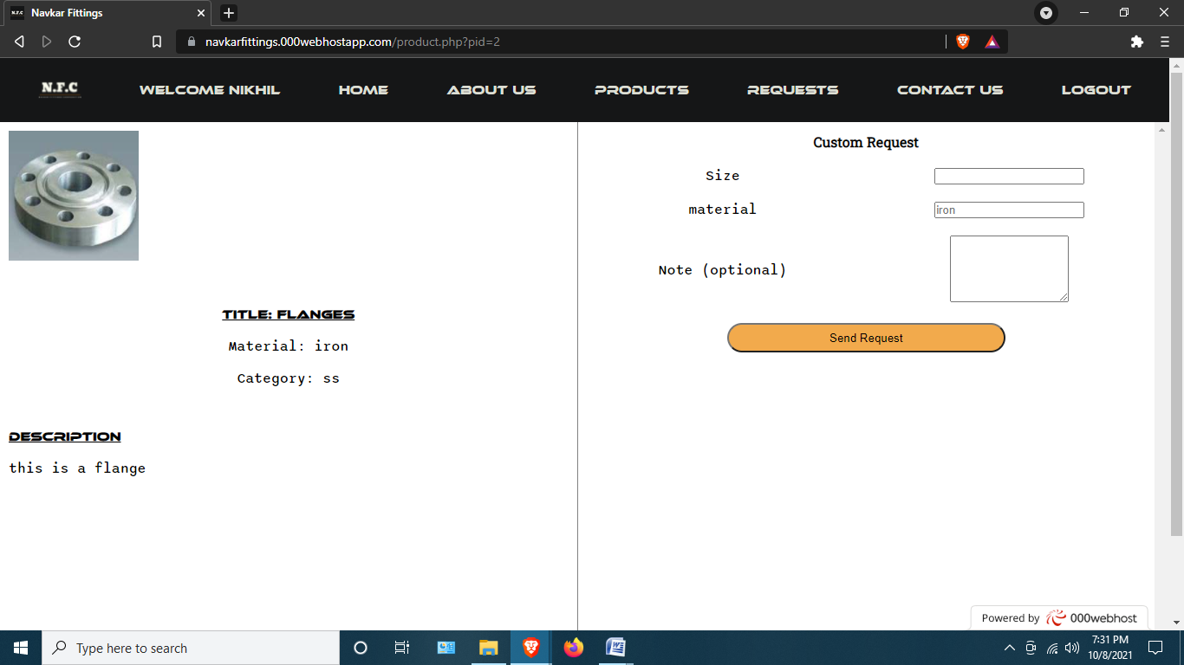

REQUESTS.PHP

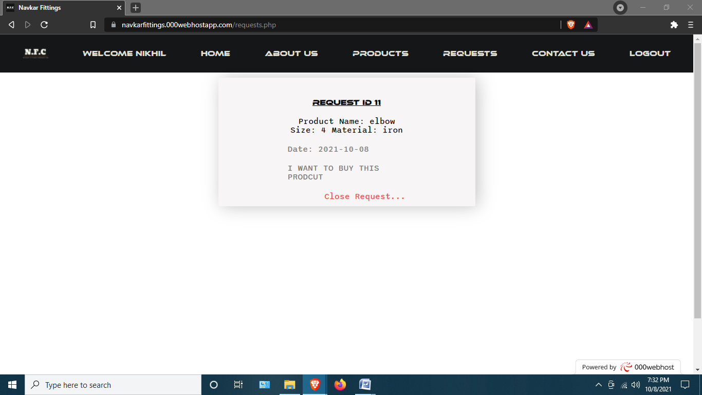

ADMIN.PHP

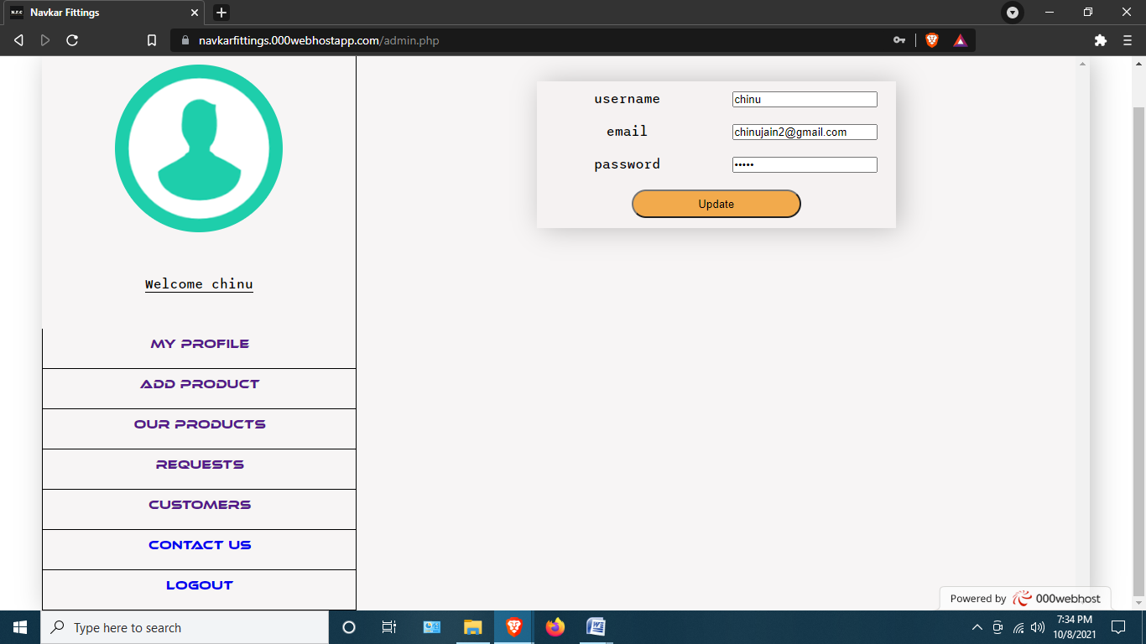

ADDPRODUCT.PHP

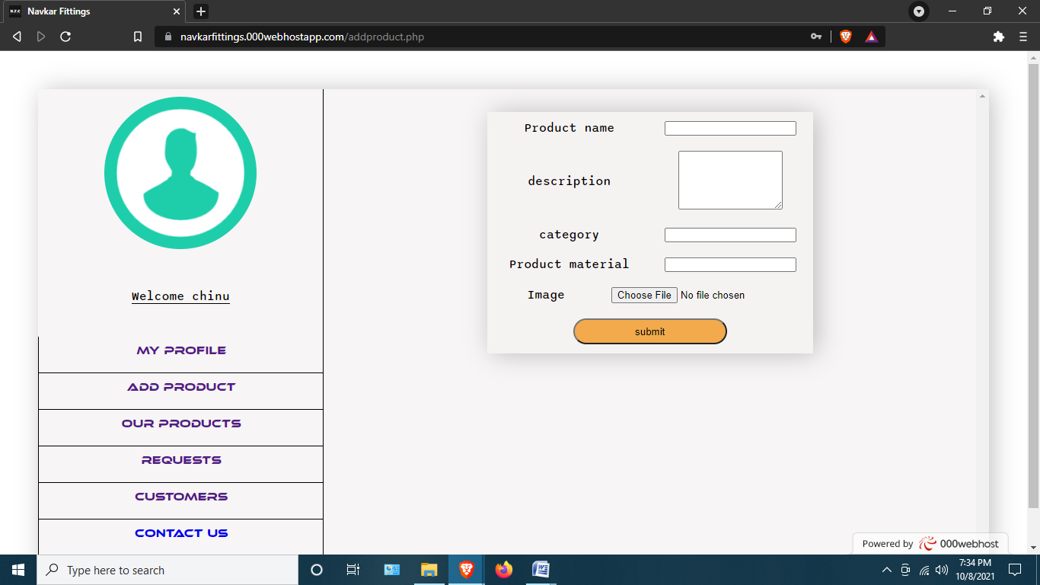

VIEWPRODUCTS.PHP

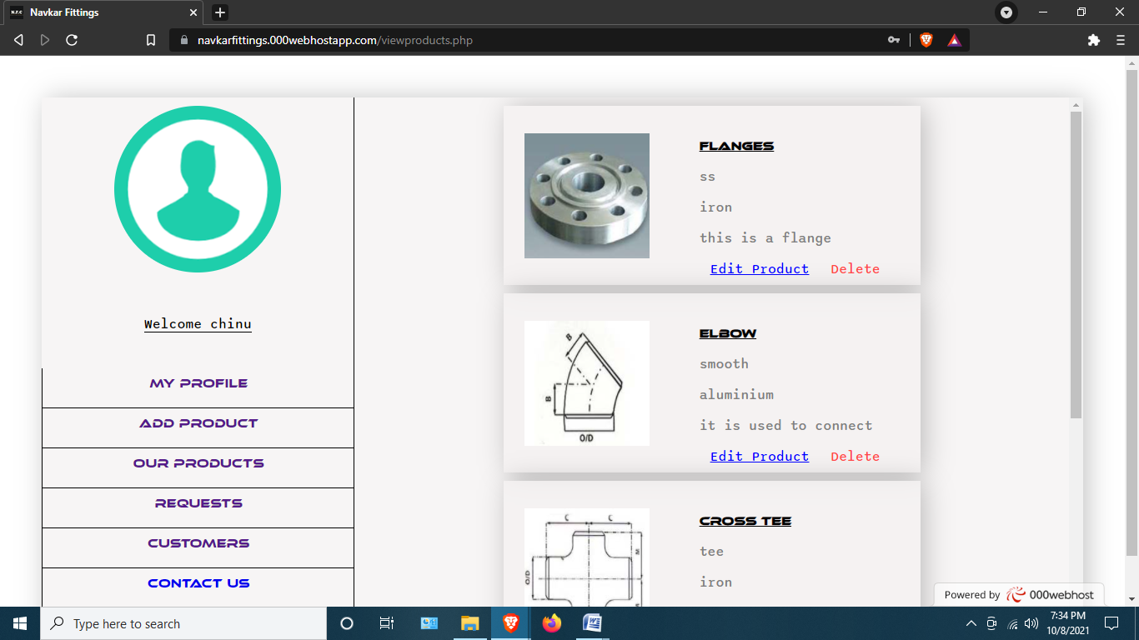

VIEWREQUESTS.PHP

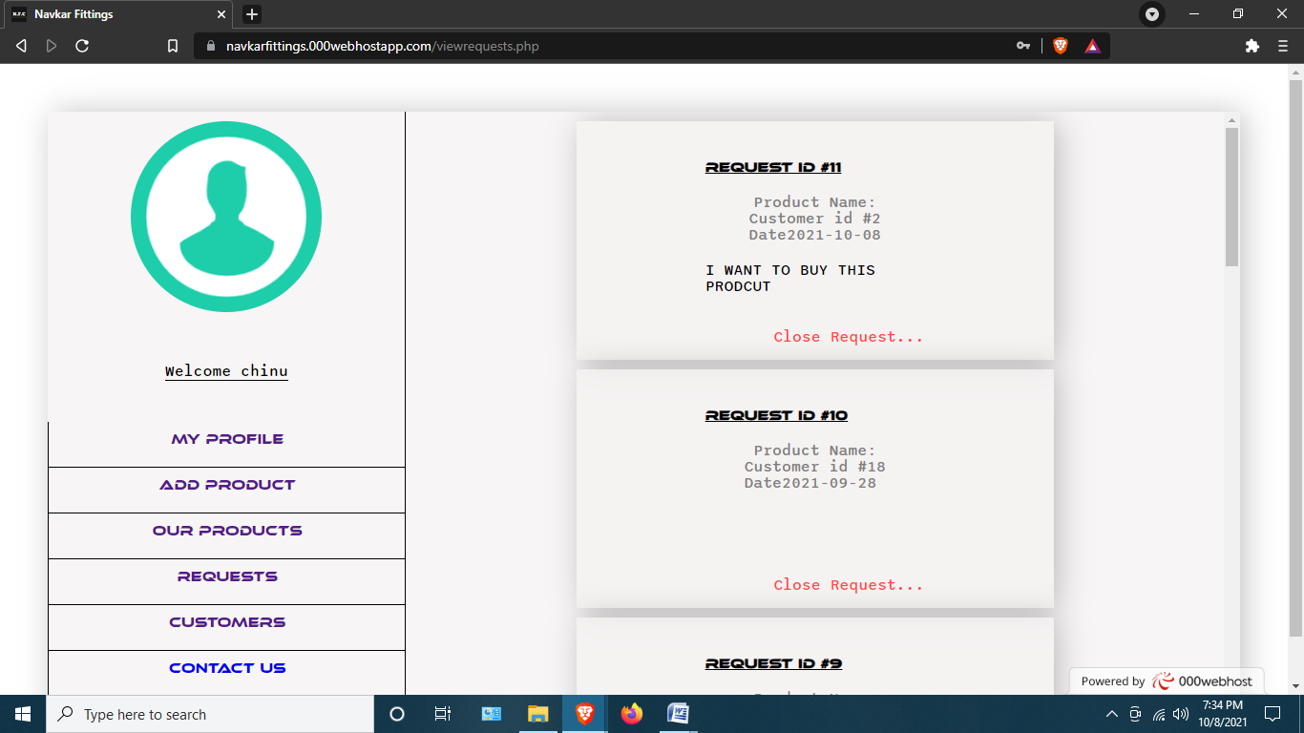

VIEWCUSTOMERS.PHP

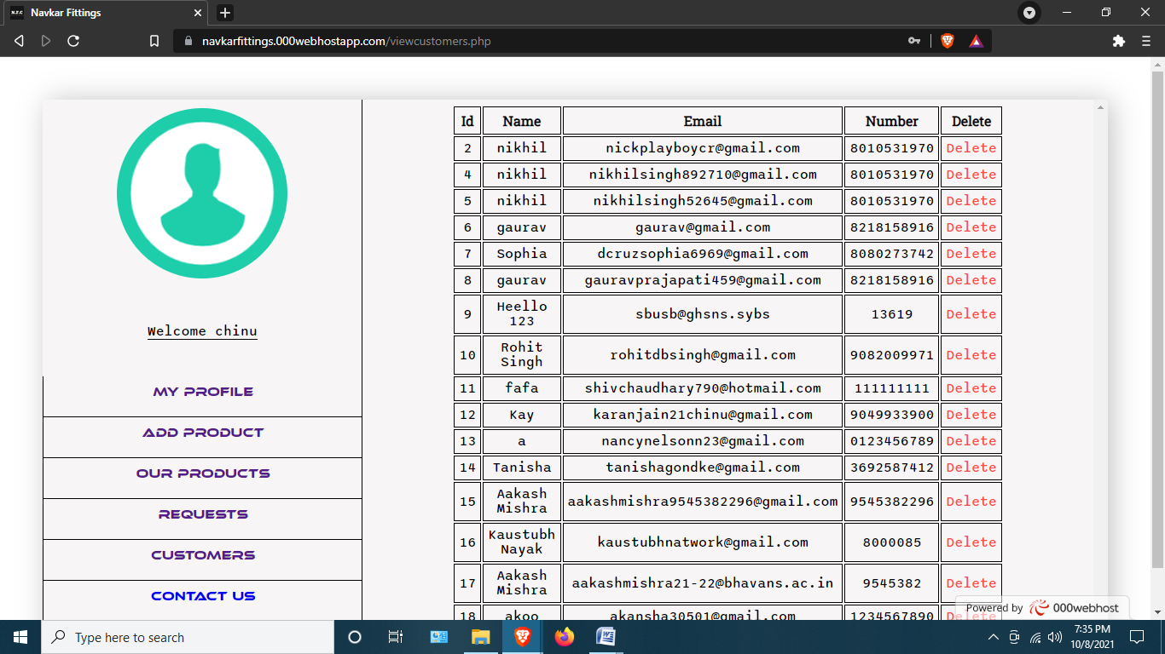

CONTACTUSADMIN.PHP

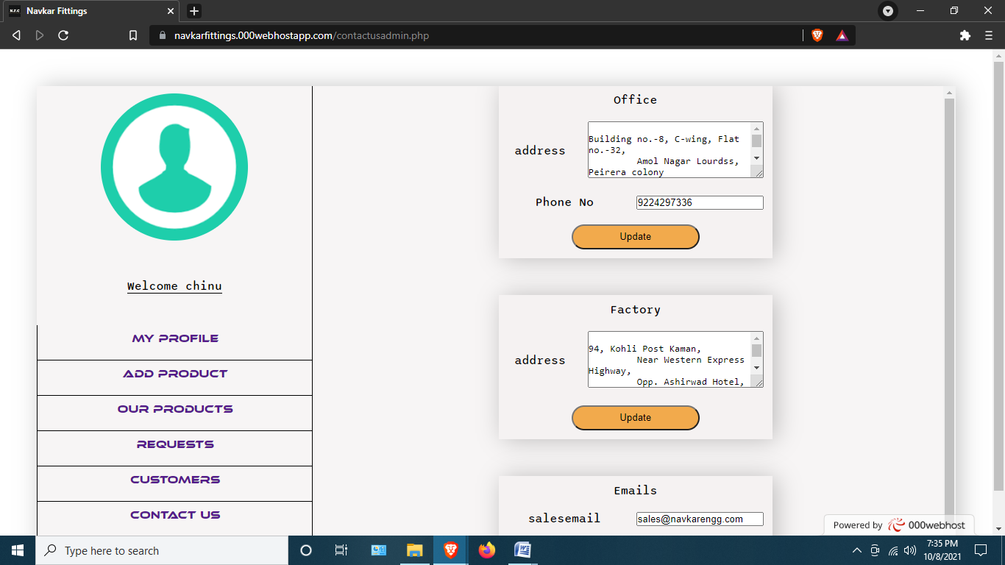

EMAILS

REGISTRATION

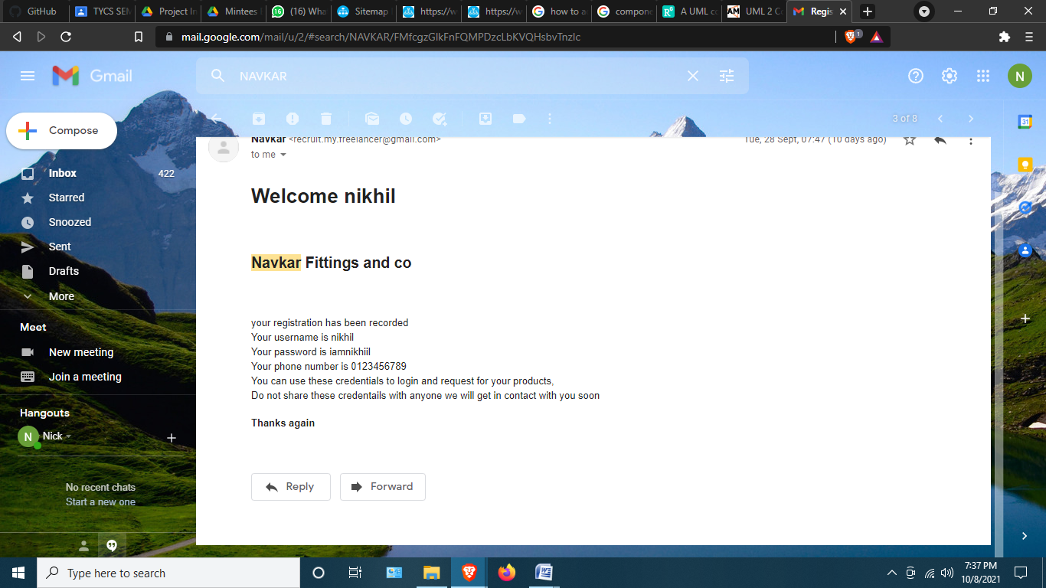

FORGOT PASSWORD

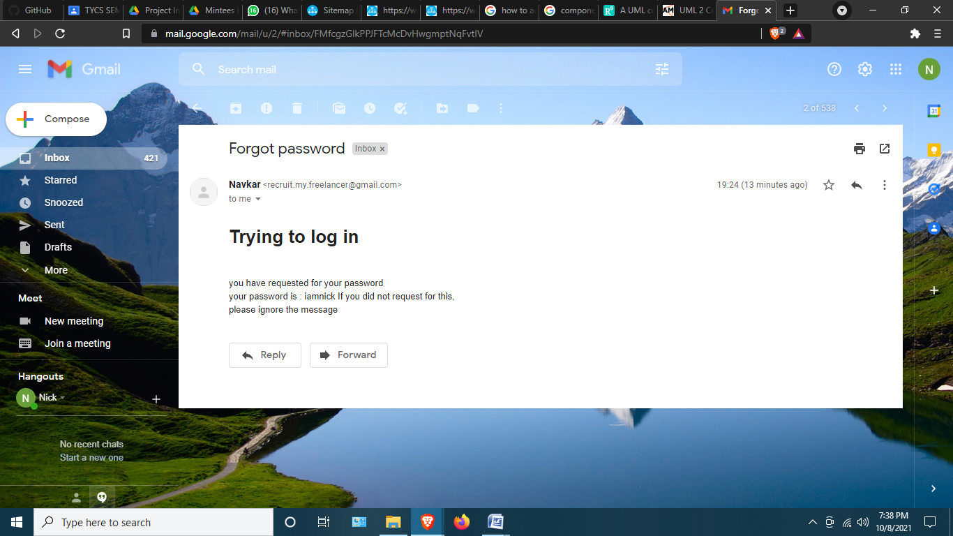

ON PRODUCT REQUEST

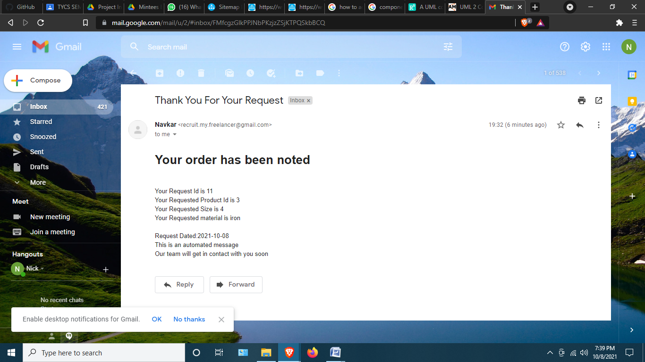

**5.** FUTURE SCOPE

* A chart will be added to all products ,with the images of the product the current part has been commented out on client request
* A live dm feature will be added for sales team
* The project will be deployed on the new domain of the firm

CONCLUSION

* An attempt is made in all its earnest towards the successful completion of the project. This system was verified with valid as well as with invalid data.
* The system is made on PHP and has a well defined gui , the customer module is also responsive and fit for any device
* The project has been open sourced at <https://github.com/codewithnick/navkar-fittings-and-co> with client consent although , this repo might be privatized later.
* The project has been deployed for anyone interested in testing at <https://navkarfittings.000webhostapp.com/> with client consent although , this link might be down later.

**6.References and Bibliography**

**WEBSITE REFERENCE**

* [www.youtube.com](http://www.youtube.com)
* [**https://www.geeksforgeeks.org/**](https://www.geeksforgeeks.org/)
* [**https://polypane.app/**](https://polypane.app/)
* [**https://app.diagrams.net/**](https://app.diagrams.net/)
* [**https://stackoverflow.com/**](https://stackoverflow.com/)
* [**https://css-tricks.com/**](https://css-tricks.com/)

**SOFTWARES USED**

1. FOR DESIGNING

* Draw.io
* Vscode

1. FOR CODING

* Vscode
* Xampp
* Polypane

1. FOR DOCUMENTATION

* Draw.io
* Polypane

1. FOR DEPLOYMENT

* WEBHOSTAPP000

**EXTERNAL LIBRARIES USED**

* PHP SMTP Lib